**CLASS 08/02/2022**

**GRAPH THEORY**



**How a graph is represented in computer?**

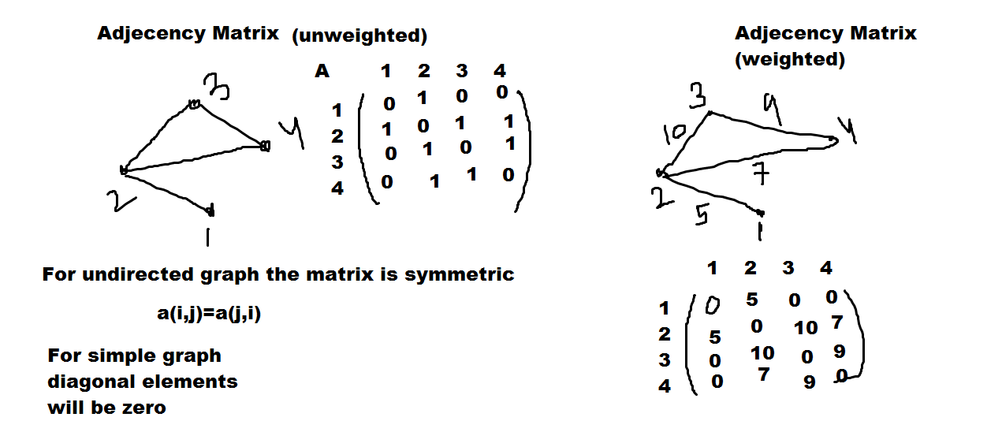

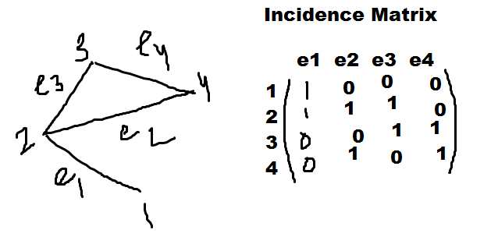

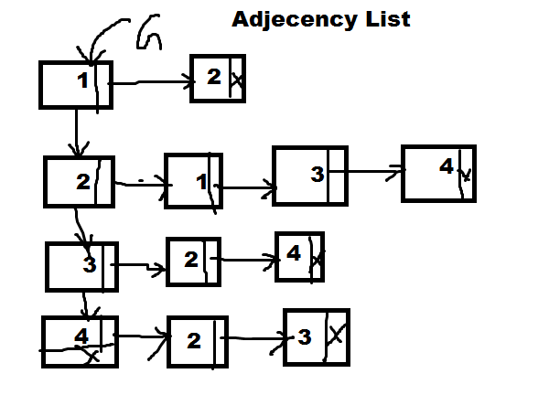

**Spanning tree of a weighted graph**

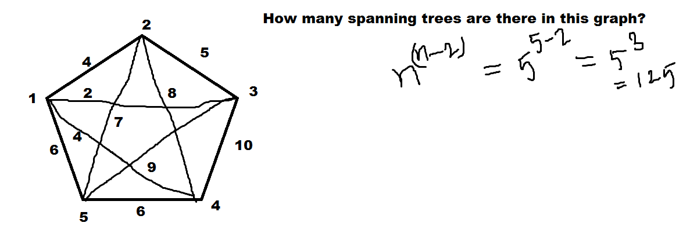

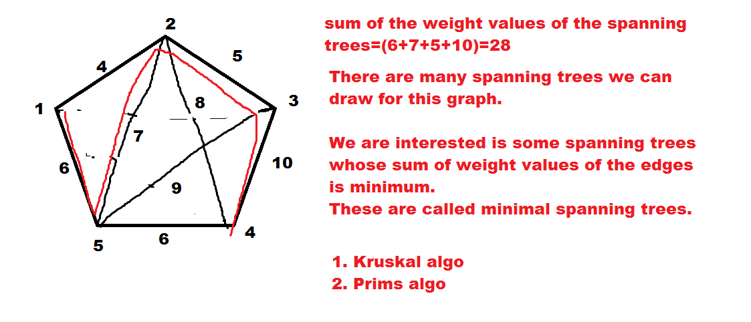

**Kruskal Algorithm**

* Sort the edges of the graph on weight values in ascending order
* Select the edges in ascending order and add the edges in NULL graph consecutively such that adding an edge does not form a cycle.
* Stop the process of adding edges when n-1 edges added where n=order of the graph.

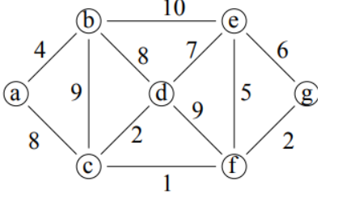

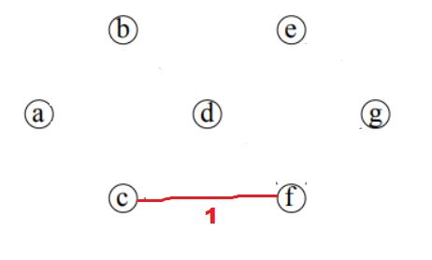

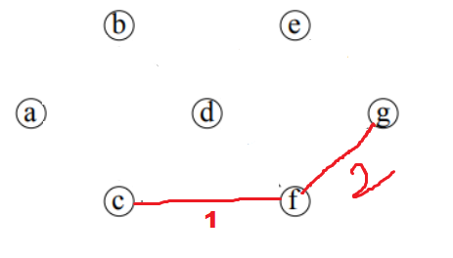

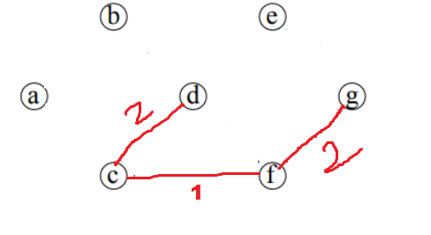

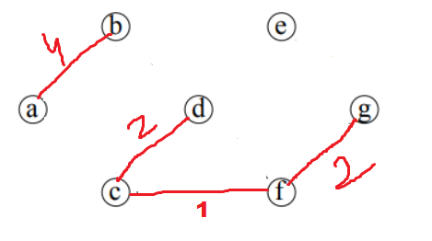

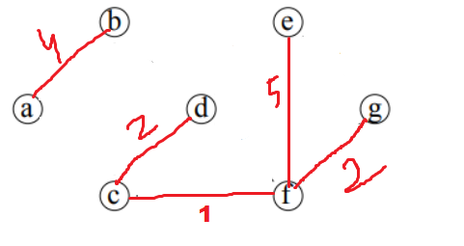

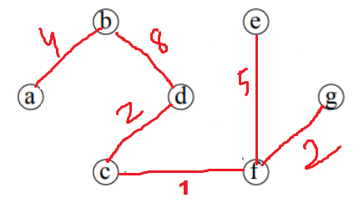

**Minimum spanning tree=(4+8+2+1+5+2)=22**

**Cycle Detection Algorithm**

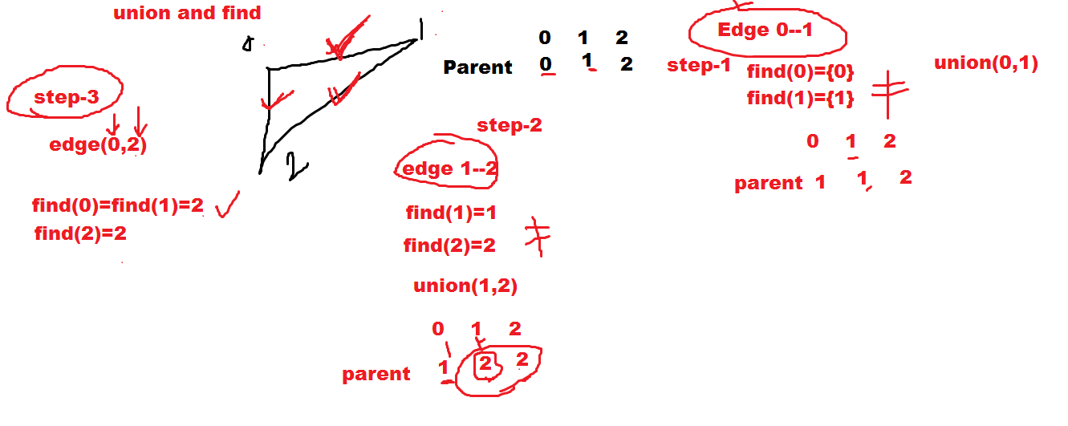

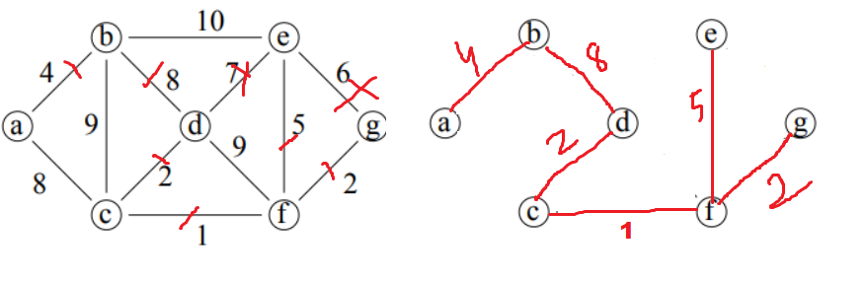

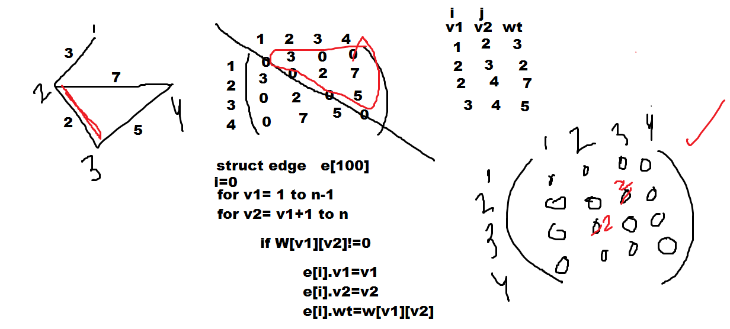

**Prim’s Algorithm**

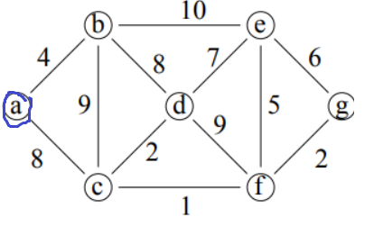

Select any arbitrary vertex say a, make two vertex set

V1={a}

V2=V-V1={b,c,d,e,f,g}

Now the edges S whose one end vertex in V1 and other in V2 are called cross edges. Select the lightest cross edge e from S and add the end vertex of e that is in V2 to V1.

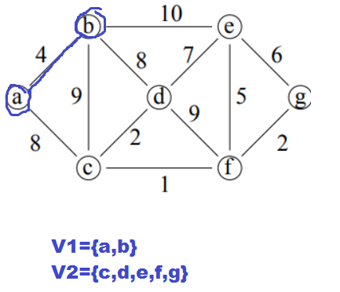

Now repeat the process until V2 becomes Ф.

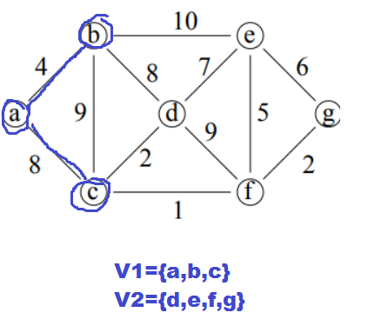

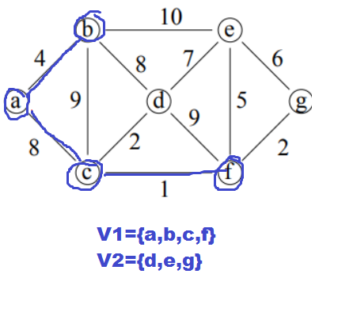

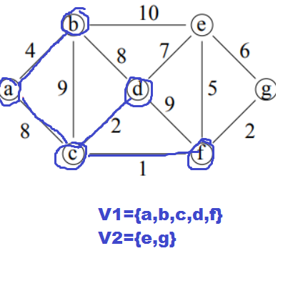

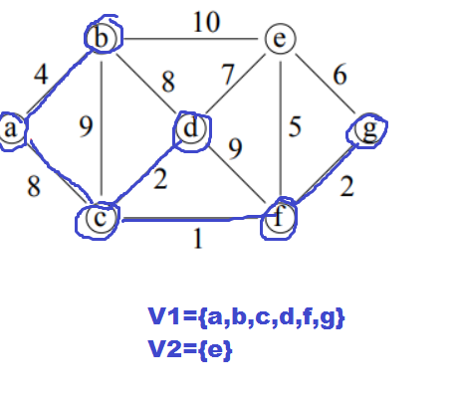

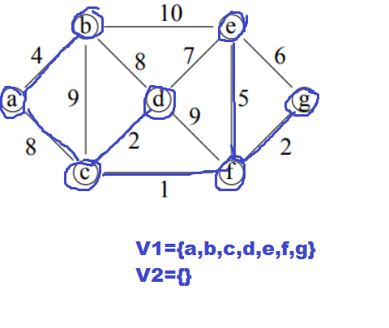

Cost=(4+8+2+1+5+2)=22